37.76: For any function 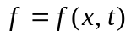and 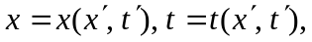 let 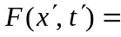
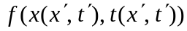 and use the standard (but mathematically improper) notation 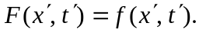 The chain rule is then
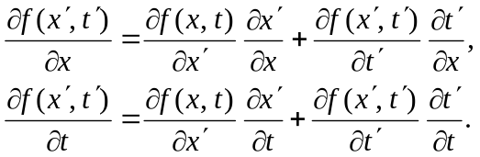
In this solution, the explicit dependence of the functions on the sets of dependent variables is suppressed, and the above relations are then
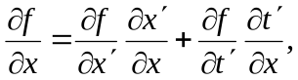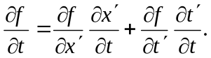

a) For the time derivative, 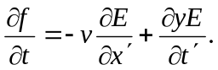 To find the second time derivative, the chain rule must be applied to both terms; that is,
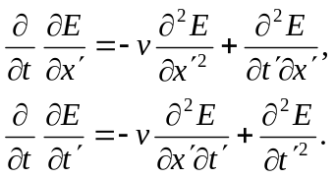
Using these in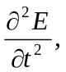 collecting terms and equating the mixed partial derivatives gives
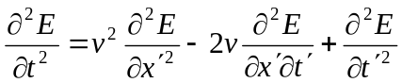
and using this and the above expression for 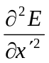gives the result.
b) For the Lorentz transformation, 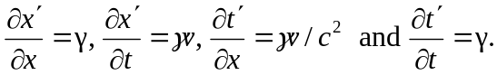
The first partials are then
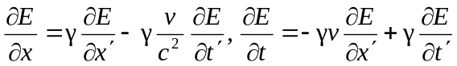
and the second partials are (again equating the mixed partials)
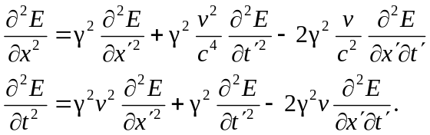

Substituting into the wave equation and combining terms (note that the mixed partials cancel),
